Lab: Mapping, Part 2

The goal of this lab is to gain a deeper understanding of how you interpret a text by mapping it, and to familiarize yourself with some of the more advanced representation and embedding features of Google Maps.

For this lab, you can either work with a text you’ve brought in or continue your “Araby” map from last time. If continuing an “Araby” map, ask yourself, What works on the map you’ve already done? What can be improved? Then, develop a plan for revising or re-making the map, and go about executing it.

Map Features

Try different ways of using the “Draw a line tool.” Using the “Draw a line along roads” options will be difficult because it adheres to one-way street directions, which in a large city like Dublin will result in all kinds of circuitous roots that are unnecessary when walking, like the protagonist in “Araby.” Instead, use the “Draw a line” tool manually to trace the paths that you think the protagonist (or your alternative literary characters) traveled.

To do that, simply select the tool and click on the map in smaller increments to make the line you need. Zoom in and out to keep the larger picture in mind and make longer increments when necessary.

Also try the “Draw a shape” tool, which allows you to circumscribe a region and tint it with a color of your choosing. Are there certain zones that are significant in “Araby” or the piece you’re working with?

Embedding Features

Control the presentation of your map on a website by changing the map style and setting the display size. To do that, click on the link icon, top left, and then on the “Customize and preview embedded map” link.

In the following window, set the height and width pixel sizes for the embedded version (650 is a good option for our course website). Think about how you might use a large map or series of small maps on the wiki, for instance.

You can also choose between the Map, Satellite, Terrain, and Earth views by clicking on the tabs at the top right of the image, depending on what suits your presentation needs.

Also, reorient the center of the image and zoom to control exactly how it will appear upon loading when embedded.

The copy-paste code at the bottom will change as you make adjustments. Once you’ve finished, copy-paste the code into the Source view of the course website, and check the results.

How to embed images in Google Maps pin bubbles.

- Find or create an image. (I took a screenshot from a Street View image of the Araby House).
- Upload the file to an image sharing service like Flickr.com or similar. There is a course Flickr account you are welcome to use:
tulsadigitalhumanities
Hurricane365
- Make sure the image is given a public, Creative Commons license so that it can be shared.
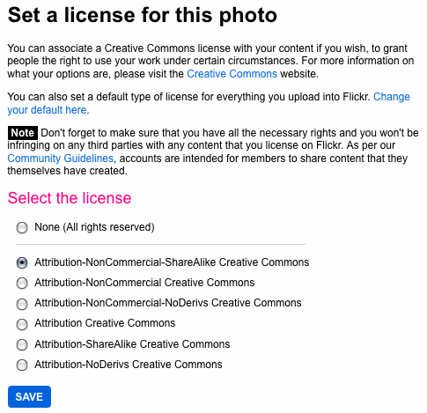
- Browse to the image, click on the Share button, and grab the embed code.
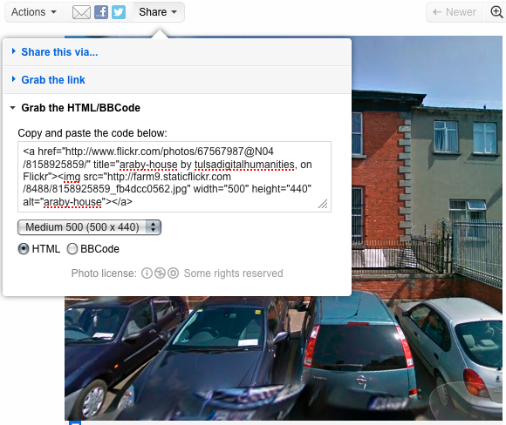
- Click on the big red Edit button in your Google Map.
- Click on the pin to which the image corresponds.
- In the bubble, click on “Edit HTML”
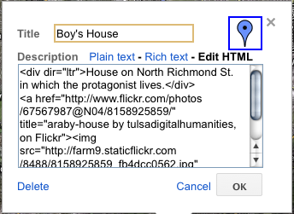
- Copy-paste the image embed code into the description box where you want the image to appear.
- Adjust the width and height as desired.
- Click on Save and then Done in the left sidebar.
- Click on the pin to make sure the image appears in the bubble.

