Lab: Mapping “Araby”

This lab introduces students to the mapping of literary texts with simple tools such as Google Maps. Each student will create a map based on plot elements or some other aspect of “Araby” and then embed it in a post to the course website.

- Before starting the lab, decide what you wish to map. It could follow ideas such as the ones that came up in the previous class: charting physical location vs. mental location (i.e. he’s in one place thinking about Mangan’s sister in another), the places where the stages of the romantic quest occur, the walks and tram ride to “Araby,” or any other theme you might think of.

- Once you’ve decided on a procedure, go through the story to find all the places in Dublin pertinent to your inquiry, and then locate them in Google Maps. Place a pin at each location, drawing lines along the routes if you wish to document the narrator’s travel. Then, look at the whole and see if there are any patterns that help you to read the story or suggest questions.

- After all the pins are labeled and on your map, get the embed code, copy-paste it into the course website, and write a brief description (1-2 paragraphs) of what you’ve done and what suggestions or insights it provides.

Instructions

- Log in to Google Maps with your Google ID (i.e. Gmail) at http://maps.google.com

- Click on the “My Maps” link in the upper lefthand corner and then on the “Create” button.
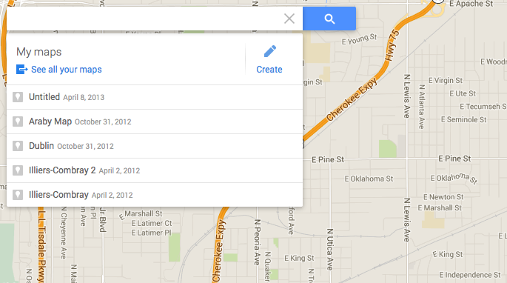
Give your map a name and description by clicking on “Untitled map.” It will now be listed under the “My maps” tab at the top left every time you log in to Google Maps.

- In the search bar, type “Araby House, Dublin, Ireland” (without quotes) to arrive at the location on North Richmond street where the story is set. Click on the green pinpoint and select “Add to map.”
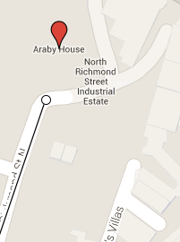

- Familiarize yourself with the Google Maps interface near the top. You can search the map, drop pins to label locations, draw lines, write directions, and measure distances. The left and right arrow buttons allow you to undo and redo steps as you add features to the map. Zoom controls are the “+/-” button near the bottom right, and on the scrolling ball of your mouse.
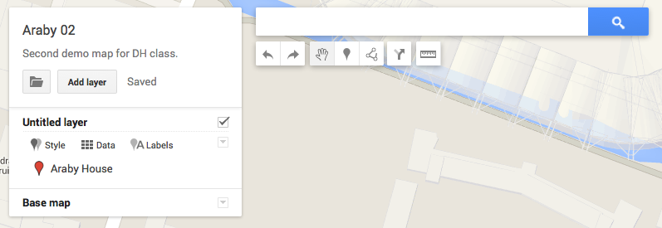

- To add a location, click on the pin button, which will turn your mouse cursor into a “+,” and then click on the location of the map you wish to drop it. In the following dialogue, you can add a name and description, as well as an image or video (using the camera button). Perhaps you’ve found an artwork or photograph illustrating some aspect of “Araby” that you’d like to add?
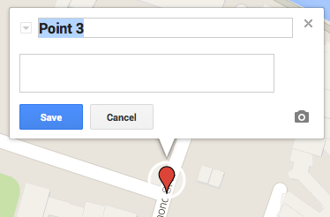
- As you add labels to the map, a list of them appears in the overview box at top left. Labels can be given different colors – either individually or according to a schema – and various layers defined. Thinking back to our readings about graphical primitives adding interpretive layers onto a visualization, perhaps there is a way to color-code your map so that its analytic purpose is made clear.
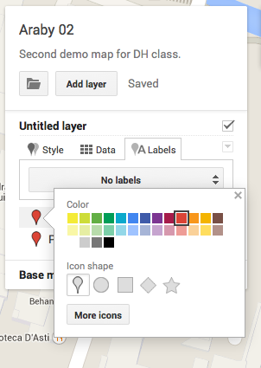
- Tracing routes: Given the narrator’s love of walking, we can potentially trace some of his routes to gain a sense of how he moves in the space of the countryside, and how this affects or derives from his memory.

  - Click on the dot-and-line line button under the search bar.
  - The cursor is now a “+” : click on the spot where the route starts, and keep clicking along the path you intend to follow until arriving at the last spot. Pay attention to street curvature so as not to draw walking routes that go through buildings, canals, etc.
  - Use the left arrow under the search bar to undo any mistakes.
  - Double-click on the last spot to end the route function, and give the route a name and description. You may also add photos or video with the camera button at bottom right.
  - Click once where you want the line to start and mouseover to the point where you want it to stop. Play around with this feature and make use of the Undo option if you make a mistake.
- Note: You may need to search for streets like Buckingham or the location of the “Araby” bazaar (hint: Royal Dublin Society Showgrounds in Ballsbridge), which might be easier to do in a separate window.
- About 10 minutes before the end of class, embed your map in a blog post on the course site, and provide a description of what you attempted to do, and what the map shows about “Araby.”
  - First, click on the green “Share” button at top right to make the map embeddable/exportable.
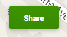
  - You have options as to how the map is shared. You may make it public on the web, available to anyone who has the link (which ostensibely is not discoverable otherwise), or public on the web. For our purposes, please choose public on the web.
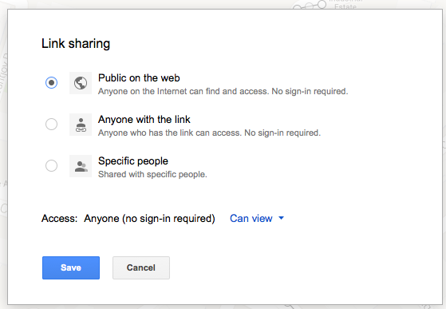
NB: You may also invite collaborators to be able to edit the map, as opposed to merely viewing it. This may be done in a final project if you wish.
  - Click on the blue Save button, and a stable link to your map will be provided for sharing. Click on the blue “Done” button when finished.
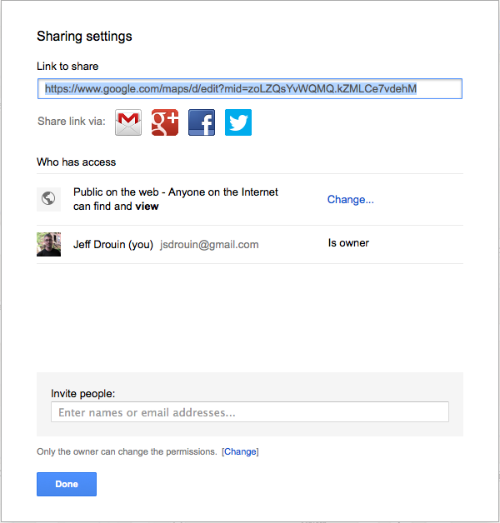
  - Click on the folder icon in the map overview area and select “Embed on my site” from the resulting menu.
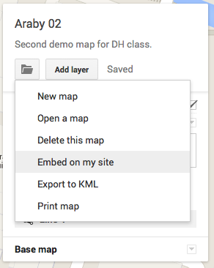
  - Use Ctrl-C or Command-C to copy the <iframe> embed code.
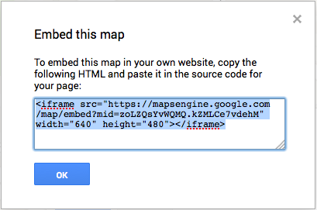
  - Log in to the course blog, create a new post, and then click on the Source button to paste in the embed code. You can fiddle with the width and height by setting the pixel values in the code (under width=”640” etc.). Use the Preview button to see how the map will appear before posting.
